# IE 643 - DL

Grades :

Quizzes - 15%

Class Participation - 5%

Challenge Programming contests - 10% (Individual)

Assignment - 10%

Midterm - 20%

Project - 40% (Team of 2)

Prep assessment - 20%

Continuous assessment - 60%

Novelty assessment - 20% (beyond the project topic)

Prereq - Python, LA, Stats, Probability

GOAL : Optimisation problem formulation

Algorithms (Performance analysis)

References -

Conferences - CVPR, ACL, CASSP, INTERSPEECH, ICML, ICCR

## Imp Moodle Announcements

* Homework exercise for perceptron implementation is posted.

Please attempt the homework problems given in the slides.

The TA allocation for all teams for IE643 Course Project has been done. You can find the allotted TAs in the "TA Allocation" tab of the given [LINK](https://docs.google.com/spreadsheets/d/107ptsrvdHUkzDDh270OKx026AWXuyIGSFS7_Vl3bSGg/edit?usp=sharing). We request the teams to contact their respective TAs during the doubt/planned sessions for project related queries.

Please take a moment to read the [IE-634 Course Project Starting Tips](https://ie643projectstartingtips.notion.site/IE-634-Course-Project-Starting-Tips-7069afad196e454bbe47f002589a29ff?pvs=4). This will provide some guidance, techniques, and approaches on how to begin your course project

Please find the demo code for Multi-layer Perceptron by [clicking here](https://colab.research.google.com/drive/1_nX0Hr3Ra6Wc6XrH9H49rokSeyMt2tZg?usp=sharing).

There are some portions of the code with a ### TODO: tag.

Please attempt them by using the expressions derived in class for forward and reverse pass.

## **Assignment 1 Correction:**

A clarification in Question 1 (d) in IE 643 [Assignment 1](https://moodle.iitb.ac.in/mod/assign/view.php?id=41316):

Please note that in Question 1 (d) the first four columns in data1.csv, data2.csv, data3.csv should be considered as features.   
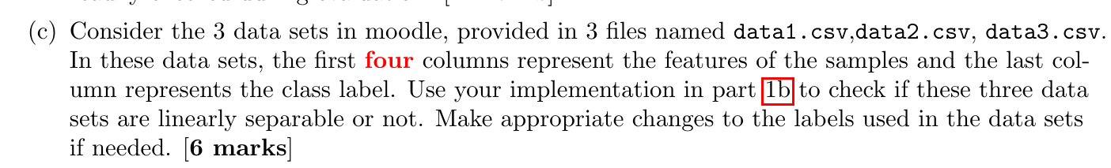

## **Project**

[IE-634 Course Project Starting Tips](https://ie643projectstartingtips.notion.site/IE-634-Course-Project-Starting-Tips-7069afad196e454bbe47f002589a29ff?pvs=4)

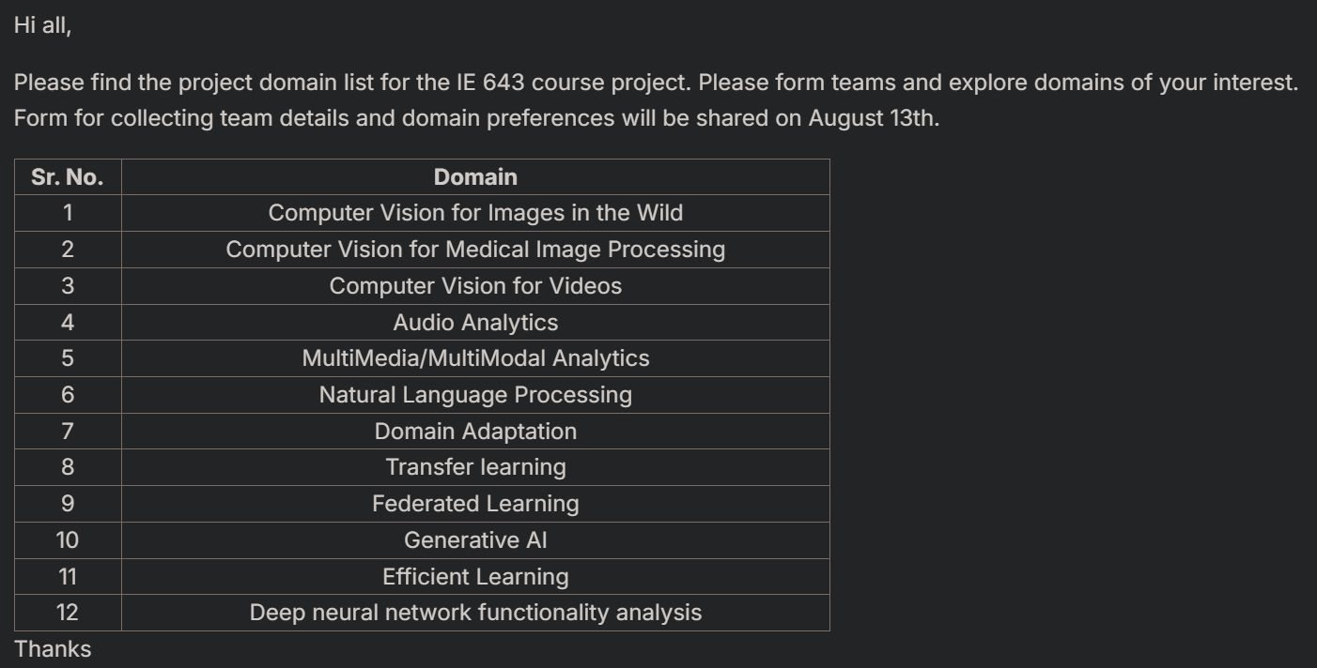

* IE 643 course project timeline [here](https://docs.google.com/spreadsheets/d/107ptsrvdHUkzDDh270OKx026AWXuyIGSFS7_Vl3bSGg/edit?usp=sharing).
* a team can not have more than two members under any circumstances.

crediting students cannot team up with students who have not registered for the course.

## **Extra Exercises from Coding Session:**

Please have access to PyTorch MLP notebook [IE643-2024-PyTorch-MLP](https://www.kaggle.com/code/aashish31476/ie643-2024-pytorch-mlp), please note that this is a kaggle notebook.

Exercises:

1. Try to create a training function that can take a model, dataloaders, loss function, optimizer, device, epochs, etc.

2. Try using other optimizers such as Adam, AdamW, etc.

3. Try to implement inference function which will take model, train_dataloader and test_dataloader and will give prediction .csv form.  
  
5. Plot Confusion Matrix for train prediction and test prediction.

6. Try to add functionality of k-fold training in the training function.

7. Try implementing an MLP Regressor.

8. Modify the training loop so that at every best score the model checkpoint is saved (replaced).

9. Add functionality to resume training if it gets interrupted.

Please try these excercises they will help you a lot in running your project experiments on Kaggle.

## **Programming Challenge**

IE 643 Programming challenge is available at the following Kaggle link: <https://shorturl.at/7SFPh>

You must attempt the challenge only at this Kaggle link. This challenge is to be attempted individually.

If you have a Kaggle account you are free to use it. If you do not have one, please create a Kaggle account to attempt the challenge. You might be asked to provide a contact number during Kaggle account creation. Please note that Kaggle does not allow multiple accounts to be linked to a single contact number.

Please read all instructions carefully in the above Kaggle link before attempting the challenge.

If you have any queries please use the [discussion forum](https://moodle.iitb.ac.in/mod/forum/view.php?id=33969) in Kaggle or in moodle to post your doubts.

A public leaderboard will display the top ranked submissions along with the team names. You are free to submit as many as 100 submissions per day to test your models.

Anytime during the duration of the challenge (10th November 1:30 AM till 28th November 11 PM Indian Time), you can choose to make the final submission. For the final submission, you need to choose only two best solutions (obtained from two of your best models) which will be used for ranking in the private leaderboard.

The top 5 ranked teams in the private leaderboard will receive extra points towards grading and their solutions will be highlighted for all the participants. The top ranked teams will also be invited to provide a description of their models in Kaggle.

We will also float a Google form later to collect your roll number, name displayed in leaderboard, and link to all files related to the challenge.

Good luck !

## **Coding Announcements**

Please watch [this video](https://drive.google.com/file/d/1tbOtWXXPCWTmVg1aawWZyPviK2io9LPS/view?usp=sharing). It covers most of what you need to know to get started. Also check these for more, Please use your IIT Bombay email id to access this video

[Efficient GPU Usage Tips](https://www.kaggle.com/page/GPU-tips-and-tricks),

[Session Persistence for Variables and Files!](https://www.kaggle.com/discussions/product-feedback/355440)

torch fundamentals:  
<https://colab.research.google.com/drive/1IiXOyOMr22p73ghTRE9vw33uxPiiDWK6?usp=sharing>

data reading and pre processing of image dataset (MNIST) :  
<https://drive.google.com/file/d/1U4eaAmsN67GRurh8jzWkfsIl503qx30t/view?usp=sharing>

Image Data and Custom Data: <https://drive.google.com/file/d/1-W_FE1Y74b7WhCc242wiKcbaYVBP1tjn/view?usp=sharing>

Text Preprocessing:  
<https://drive.google.com/file/d/12MXVvxiFL9tcz_tWayz2bZA-jmS_n3Sw/view?usp=sharing>

LeNet5 architecture notebook: <https://colab.research.google.com/drive/1qEAcEu3k7t1Fufvboj1ffLyQsKxsUFsG?usp=sharing>

VGG architecture notebook: <https://drive.google.com/file/d/1lx02GwUR1Ss1ygddZujsbs9B2t0DtNMx/view?usp=sharing>

ResNet 18 Notebook link: <https://drive.google.com/file/d/1qe2jCWdR5bLe8anBBnkHkgQoujsMPdk8/view?usp=sharing>

Dense Net Notebook: <https://drive.google.com/file/d/1hMIxbHjWolOi3qy_Be7eX4fDf1cQMX3g/view?usp=sharing>

RCNN Notebook: <https://drive.google.com/file/d/19b_6zGjeCNQnAemjiufhrgsM0yKRdnzU/view?usp=sharing>

GAN <https://colab.research.google.com/drive/1Sx8fznmmV43Zaf1auIHPjn4gBnUkcCyq?usp=sharing>

VAE <https://colab.research.google.com/drive/1oUfvb03CWO-nhiWGF4QSI731DYSvoi_6?usp=sharing>

IE643_VAE_Mnist_class: <https://drive.google.com/file/d/1LBb5zqLKxwxfaBDEvdxdFsjFo2JYJIyv/view?usp=sharing>

IE643_GAN_MNIST_2024: <https://drive.google.com/file/d/1bfTWhgkoqtFcmn4efZ-ylJIyZwEQHzYB/view?usp=sharing>

IE643_GAN_CIFAR_10_2024: <https://drive.google.com/file/d/1CMmrBTszblcqbynhHE0EPGsbqw8HlYAZ/view?usp=sharing>

Please find the notebooks for today's demo on RNN, LSTM and GRU.

<https://drive.google.com/file/d/1--NNCPqnXzhV8x6Z9Bb4lLWqbFnjU_sP/view?usp=sharing>

Demo on Transformer

<https://drive.google.com/file/d/1z0zcJpqeucwHFf0X6PpWIjYMdng0zgDK/view?usp=sharing>